Astronomy And Particle Physics

# It all started with the Big Bang!

1. Let’s start by asking a basic question which was first asked almost millennials ago that formed the basis of modern basics;

***“What is everything(matter) made up of. Is matter continuous or discrete?”***

1. For many centuries people believed that matter was continuous in nature. They formed this hypothesis because everything they saw around themselves looked as though it was continuous. For example, flow of water, roads, sheet of paper….etc.
2. But there were others who believed that matter was discrete and not continuous. Democritus(a Greek philosopher, mathematician and astronomer) is credited to name the small discrete particles which in cluster form matter. Democritus called these small particles ‘Atomos’, which translates to ‘unbreakable’ in Greek.
3. And as any other new idea, this new idea of atoms being the smallest unbreakable particle in nature had many critics, and this “atomic” debate continued for an entire millennia.

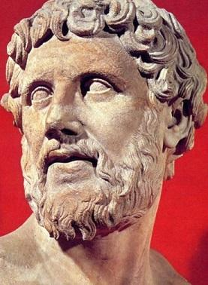

“DEMOCRITUS”

1. And while this atomic debate was still in pace, physicists developed a theory of heat , called ‘Thermodynamics’, which at that time became very effective in describing the behavior of gases. One of the many marvels in the field of thermodynamics in that its laws have remained virtually unchanged over a century and are still accurate.
2. In the 19th century, the connection between heat and mechanical energy was established quantitatively by Julius Robert von Mayer and James Prescott Joule, who measured the mechanical equivalent of heat in the 1840s. In 1849, Joule published results from his series of experiments (including the paddlewheel experiment) which show that heat is a form of energy, a fact that was accepted in the 1850s
3. And in the second half of he 19th century, Ludwig Boltzmann(Australian physicist and mathematician) developed a successful theory based on the assumptions that matter was indeed made up of a vast number of atoms.

*“*[*https://en.wikipedia.org/wiki/Maxwell%E2%80%93Boltzmann_statistics*](https://en.wikipedia.org/wiki/Maxwell%E2%80%93Boltzmann_statistics)*”*

1. But even after his remarkable work Boltzmann was not rewarded the way he should be. Many scientists criticized his theory and said that his atomic assumptions were unproven and unjustified. They demanded direct and actual evidence. There were people who asked him to show them an atom if there was one. To top this up, Ernst Mach(Australian physicist) and Wilhelm Ostwald(German physicist) promoted an alternative theory called ‘Energetics’ with rejected the existence of atoms.

[*https://en.wikipedia.org/wiki/Energetics*](https://en.wikipedia.org/wiki/Energetics)

1. Unable to show direct evidence, Boltzmann’s atomic theory waned. This had a huge emotional impact on Boltzmann and he finally ended his own life on 5th September, 1906.
2. But few years later after Boltzmann’s death, Albert Einstein finally rested the long ‘atomic’ debate when he proved the reason behind ‘Brownian Motion’ and convinced the world that Boltzmann was indeed right!

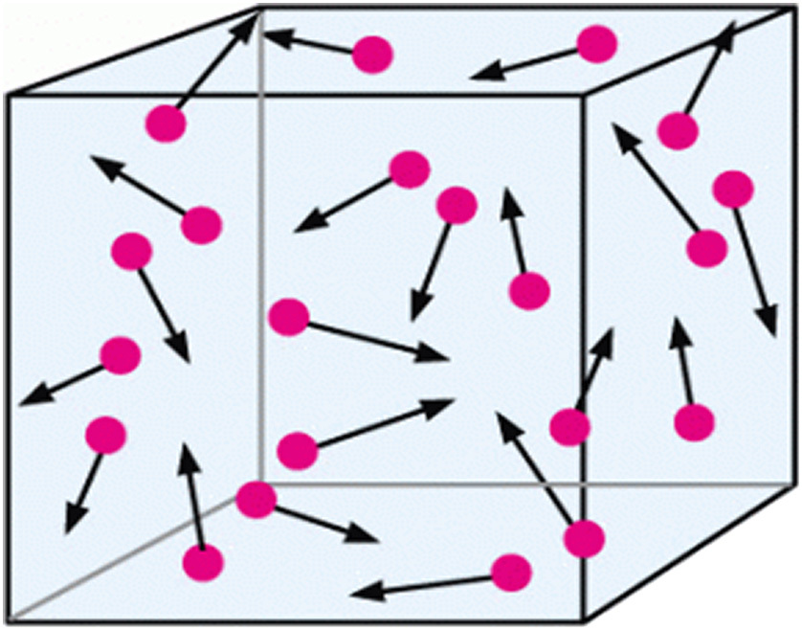

1. But how did Einstein do this………
2. In 1827, Robert Brown(English botanist) used a microscope to observe and study about minute pollen grains when suspended in a liquid. When he saw through the microscope he observed that for no apparent reason, the pollen grains moved from one point in the liquid to another. What was so curious about this was that the pollen grains changed direction so suddenly that they had hit something. But that “something” wasn’t visible to Robert Brown and it seemed that whatever “something” was, it was invisible.
3. But Robert Brown wasn’t looking for something like this. To him this was a nuisance, as it made his observation of pollen very difficult. However this became a debatable topic among other physicists. They thought that the pollens must be colliding with something that is smaller than them but make up large of the liquid. However, while other scientists were merely making assumptions, Einstein came up with an effective way to prove this.
4. Einstein’s way of approaching this problem is what we call, “Study the forest, rather than investigating each tree”. He thought that it would be a better approach to the problem if he measured the result of many collision rather then analyzing them individually.
5. And in around 1905 – 1906 he published a diffusion equation that predicts the average distance a pollen grain travels in a liquid in a given time. The distance was shown to be dependents on the number of atoms present in a given amount of liquid. Einstein’s equations were confirmed later by Jean Baptiste Perriin(French physicists) who received a Nobel Prize in 1926 for his work in physics.

“<http://wsu.edu/~collins/Brownian-poster-final.pdf>”

1. Now the question was that actually how small was an atom, what is the size in reference to which we can measure it? It was later found that the radius of an hydrogen atom(taken a reference) = 120pm. That means if we stack 1,000,000,000(1 billion) hydrogen atoms in a row it would only be approx. 30.5 cm!!!
2. The first subatomic particle to be discovered was the electron, identified in 1897 by J. J. Thomson. After the nucleus of the atom was discovered in 1911 by Ernest Rutherford, the nucleus of ordinary hydrogen was recognized to be a single proton. In 1932 the neutron was discovered by James Chadwick

*https://www.ibtimes.co.uk/timeline-discoveries-subatomic-particles-266857*

[*https://en.wikipedia.org/wiki/History_of_subatomic_physics*](https://en.wikipedia.org/wiki/History_of_subatomic_physics)

1. To get an idea about the size of the electron cloud(region where an electron is present) to the size of the nucleus let us consider an example; If we depict the size of the nucleus(proton + neutron) as the size of an average golf ball, then the electron cloud surrounding it would be spread around in a radius of 3.2 km. Despite this, the nucleus is much dominant on the atom.
2. It is surprising to note that the influence of the nucleus on the atom is about 99.97%. Also the major amount of extractable energy of an atom(>92%) resides in the nucleus of an atom!!!

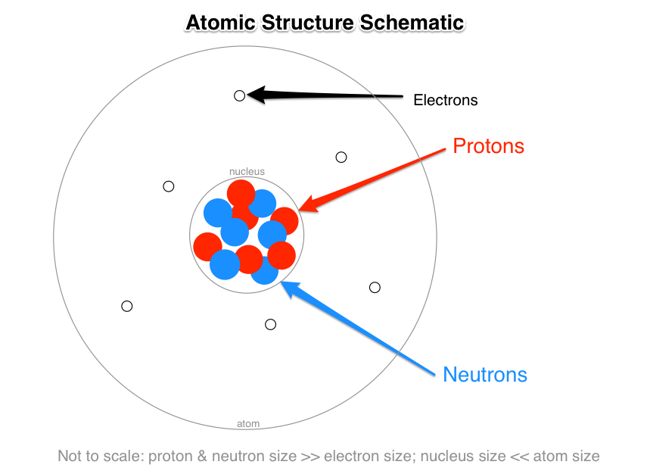

1. And it isn’t just about the neutrons and the electrons, the third subatomic particle “proton” is also very crucial. Proton decides the periodic property of an element. Here is an example to show the importance protons;

* Gold(Au):

79 protons

Inert in nature(less reactive/stable)

Very resistive against harsh environmental conditions

Cost of 1gm, 24 carat gold = Rs. 34,710 INR(as of 20th February, 2019)

<https://www.goodreturns.in/gold-rates/>

* Lead(Pb)

82 protons

Very reactive(unstable)

Cannot sustain harsh environmental conditions

Cost of 1gm lead = Rs. 0.15 INR(as of 20th February, 2019)

<https://www.indiamart.com/proddetail/1-kg-metal-lead-12410513355.html>

1. But many of these elements cannot exist in their elemental form. They need to get in homogeneous or heterogeneous groups to be present in the nature. E.g. S8 , O2 , H2 , P5 , He(inert in nature), C6……etc.…..!!

1. Out of all these, Hydrogen and Helium occupy a major space in the cosmos. Hydrogen and Helium make up to 99.8% of all the atoms and 98% of all the atomic mass in the universe.
2. But instead of calling these small particles ‘*atomos’* we call them ‘elementary particles’. But it must be noted that ‘atoms’ and elementary particles different terms and differ greatly in their meaning.
3. Atoms can be split into electrons, protons and neutrons. Whereas, elementary particles cannot be split open into anything(as far as we know today). To make this more clear it can be understood as; Electrons are elementary particles, whereas protons and neutrons are not!!!
4. This is because electrons are elementary in nature, whereas protons and neutrons are *made up of* *3 elementary particles called* ***quarks.***
5. One of the most important characteristics of elementary particles in that they are ***absolutely identical*** to each other. This can be understood with the following example;

*“Each and every electron in the universe in exactly identical to any other electron in the universe. If there is even a slightest difference between any two electrons in any part of the universe(no matter how far away), atoms would collapse and there would be no existence of life.”*

1. And not only that, each and every proton and neutron is absolutely identical to each of their kind. This is because there is only one *unique way* to join the *quarks* and make a proton, and *one unique way* to make a neutron.
2. Particles in nature are divided into two groups: ***Fermions & Bosons***

* **Fermions –** Building blocks of matter (*named after Enrico Fermi)*
* **Bosons –** Carrier of nature forces (*named after Higgs Boson)*

1. The quantum mechanical characteristics of fermions make it antisocial in nature. This is because they are forbidden(according to Pauli’s exclusion principle) to gather together in the *same quantum state*.
2. This **unique property** of fermions is the reason why matter is rigid in nature. *Material objects* are difficult to compress because the fermions in them *resist compression* due to external force. This is the very reason why our very bodies and other matter on Earth do not collapse under gravity. Thank you fermions!!!
3. Fermions are **sub-divided** into two parts;

* **Quarks –** Participate in strong nuclear force
* **Leptons –** Do not participate in strong nuclear force

1. An elementary fermion has comprises a set of **12 particle**(6 quarks and 6 leptons). They are grouped into **3 generations**(2 quarks and 2 leptons). Whereas particles with strong force are made of  **quarks.** There are six types of quarks **(up, down, charm, strange, top** **and bottom**).
2. Leptons are not affected by strong forces. They include **electron(*e*), muon(*µ*)** and **tau(*t*)**. All of them have the same electrical charge(-1).
3. Muons were first found among the cosmic rays that hit the atmosphere of the Earth. Muons are 206.77 times heavier than electrons. However these muons decay into *electrons and neutrinos in just a few microseconds*. Therefore to study these muons we need to have an handful of muons at our disposal. **One of the best ways to consistently make a lot of muons is with a particle accelerator!**
4. We can do this by accelerating an proton of Hydrogen atom(H). Then we accelerate these protons in an field and crash them into some other atomic nuclei, like lithium or carbon. The energy generated on the collision generates a mess of particles that fly out in every direction. On of the many particles that fly out, one of them is called a **Pion.** If the pions keep travelling in a vacuum without colliding with anything in the way, they will decay into **A** **Muon** or **A Neutrino** in every 26 nanosecond. The other particle generated in the collision is a **neutrino.** Neutrinos are so light and undetectable that they are also known as **The Ghost Particles.** Neutrinos interact so weakly with other particles that *they can pass through hundreds of thousands of km of steel without even* ***hitting*** *anything!!!*
5. The **12 elementary fermions** are grouped as follows;

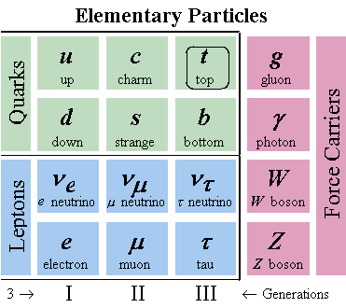

*But these are the particles in the* ***3rd dimension****. Therefore we have every possible chance to find a* ***4th dimension Neutrino*** *if there is another dimension outside our known boundaries!!!*

1. ***NOW HERE’S AN INTERESTING CONCEPT……..!!!***



***“For Every Yin There Is A Yang”***

This is a line which states the concept of dualism in the ancient Chinese philosophy describing how seemingly opposite or contrary forces may actually be *complimentary, interconnected and interdependent* in the natural world and how they may give rise to each other as they interrelate to one another. Similarly for each type of *particle,* there is ***an antiparticle*.**

<https://en.wikipedia.org/wiki/Yin_and_yang>

1. An antiparticle has the same mass of its particle partner but, all of its other characteristics are completely different.

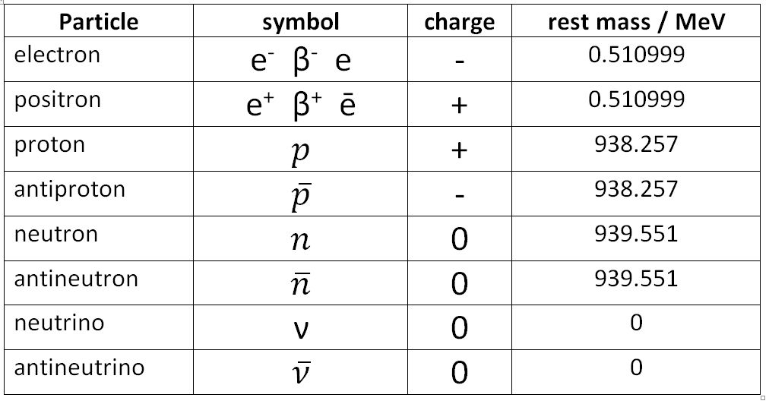

The above table shows the characteristics of *some* particles and their anti-particles. For instance an **anti-electron** has the same mass an electron but its charge is **+1.** Similarly every anti-particle has an opposite charge than its particle partner. This is what makes an anti-particle so distinct. But it doesn’t mean that only charged particle can have their anti-particle. There are also particles that are electrically neutral that too have their anti-particle. Like; *anti-proton, anti-neutron, anti-neutrino.* And we also have existence **anti-quarks** in the universe as well. For example, **neutrinos** are made of **quarks** while **anti-neutrinos** are made of **anti-quarks.**

1. When a particle and its corresponding anti-particle collide, they annihilate each other and what remains is pure energy. After this annihilation there is no trace that either of the particles even existed. When an **electron** and **anti-electron collide together** they leave only pure energy that is carried away by two photons. This can be visualized with the help of Feynman diagram;

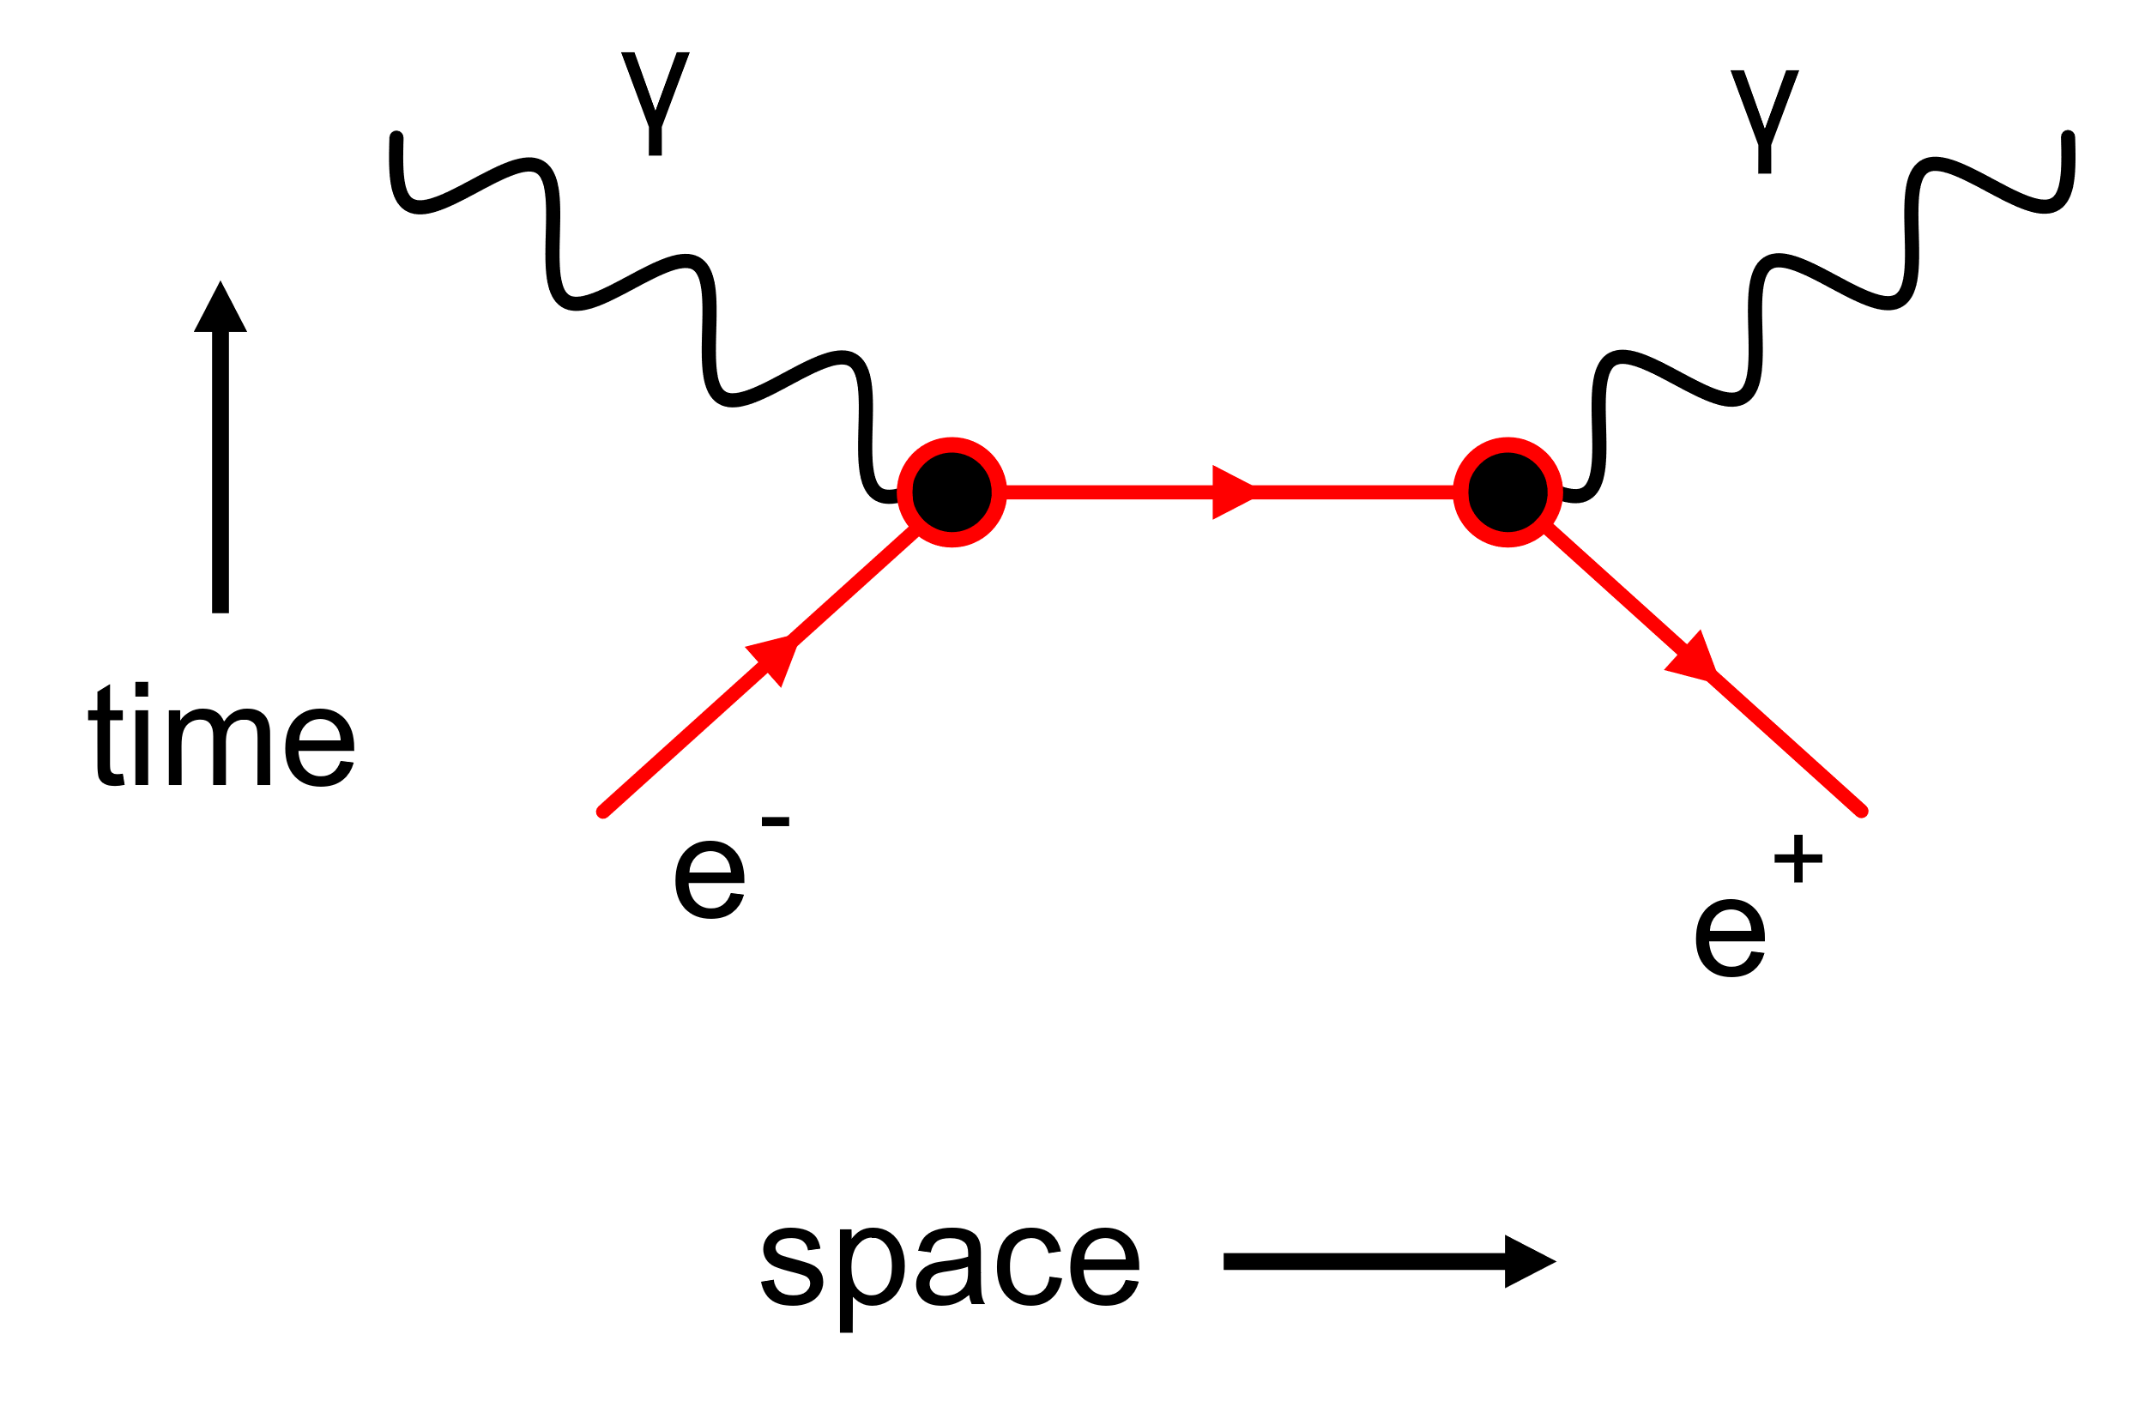

The above Feynman diagram shows how an electron(**e**-) and an anti-electron(**e+**) collide togetehr and anhilate each other leaving only pure energy which is carried way by two photons(**y**). **And the reverse is also possible, i.e.** **an electron and an anti-electron can be created by pure energy itself.**

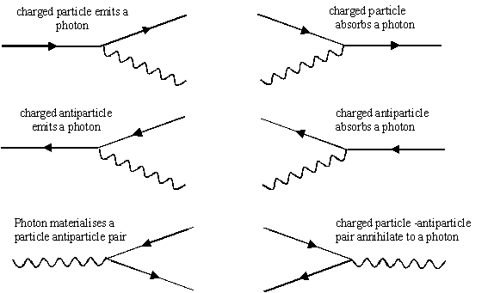

The above Feynman diagrams show how particle and anti-particle are formed from pure energy and then annihilated into pure energy on collision. In general any reaction that can occur in a group of particle can also occur in the group of anti-particle. This is called **CP Symmetry;**

* **C-symmetry**: This is called **charged conjugation** symmetry. It transforms a particle into its anti-particle or vice versa.
* **P**-**symmetry:** This is called **parity** symmetry. It transforms everything into its **mirror image**, so left becomes right and right becomes left.

<https://www.nevis.columbia.edu/daedalus/motiv/cp.html>

1. However this symmetry is **slightly broken.** And this slight break in the symmetry is very important as it explains some major phenomenon of the universe. Breaking CP symmetry means creating some particle more in amount than the anti-particles. This played an important role in the existence of the universe. Let us assume the time just a second after the existence of the universe. At that time the universe was extremely cold for new particle and anti-particle pairs to be copiously created in collisions. Antimatter annihilated with matter creating a tremendous number of photons and leaving behind the slight extra matter that had developed earlier. This caused the anti-matter to get consumed before the matter and this is why there are almost no anti-matter left in the universe and everything we see is matter. **Or is it? What if there is still some anti-matter left that did not get annihilated? So what happened to it? Can we see it? Where is this unconsumed antimatter and how did it get way from being annihilated? And if there is no antimatter why isn’t the universe filled with the enormous radiation that came out when these anti-matter annihilated. The answer to that, we still don’t know!**
2. Let us now talk about the **forces in the universe.** We now know this fact for sure that there is a force that acts on every particle in the universe. We however do not know what caused this force to come in existence in the first place. But we do know at present about the **types of forces** present in the universe. The table below shows the **4 fundamentals forces** present in the nature:

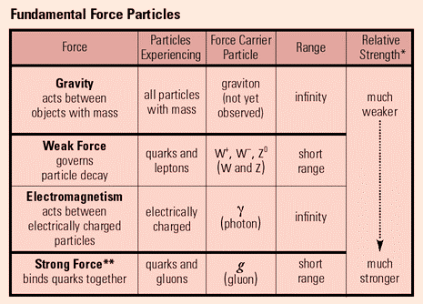

Before we go on discussing about these forces let us travel back in time and see about the debate on the nature and characteristics of force people had at that time!!!

* **Galileo** is considered the first man to study the nature and effect of force on an object when we rolled a ball of constant mass along different inclinations from a fixed horizontal level and measured its characteristics on different inclinations separately. Although he also couldn’t tell what was causing this force to occur and therefore formed is theory on the basis that “*A body will continue to be in motion or at rest until an unless an external force is applied on it.”*
* **Newton** however formulized his **3 laws of motion** in **1687** and made a major breakthrough in describing the effect of force on an object. ***HOWEVER…….***both Newton and Galileo could not explain the effect of force on distant objects – objects that are very far apart. This phenomenon is called **action at a distance.** This strange phenomenon(*at that time)* made the scientists to wonder how an object can exert force on another object without even being in contact. One such example is;

“*We all know that The Sun is 149.6 million kilometers away from The Earth but it still exerts a very considerable amount of force on The Earth”*

* No explanation at that time could be given about his phenomenon. **However** Isaac Newton formulized an expression to measure this force;

$F=G\frac{m_{1}m_{2}}{r^{2}}, (G=6.67×{10}^{-11})$

Although this formula is not completely functional, but as his equation gave correct answers for planets and objects on Earth and there was no other theory/formula, Newton’s ways were excepted and held sway for centuries!

1. The modern view of forces is as follows:

* The force between any two objects is the sum of forces between the individual particles of the objects.
* The forces between any pair of particle arises because they exchange another type of particle called a **boson.**

1. **Bosons are the carriers of force.** They are named in honor of the Indian physicist **Satyendra Nath Bose.** Bose in 1924, described a key quantum mechanical aspect of the behavior of these force exchanged particles. But as he was not a well known European, his work was denied. Refusing to face denial, Bose sent his papers to Albert Einstein who saw the potential in Bose’s work and then later published his own supplementary papers, expanding Bose’s ideas. Einstein then published both his and Bose’s papers together under the name **Bose-Einstein statistics.**

<https://en.wikipedia.org/wiki/Bose%E2%80%93Einstein_statistics>

<http://hep.ph.liv.ac.uk/~hock/Teaching/StatisticalPhysics-Part5-Handout.pdf>

1. It must be noted here that each type of force(*electromagnetic, strong and weak)* has its own type of exchange boson. The **Quantum Field Theory** is a very effective theory that deals with this.

<https://en.wikipedia.org/wiki/Quantum_field_theory> (quantum field theory)

<https://en.wikipedia.org/wiki/Bosonic_field> (bosonic field)

But this theory has still not been able to explain the cause for *gravity.* Although there is a presumption that gravity is caused to exchange of a boson called **graviton.** But **graviton has not been detected yet**. In theories of quantum gravity, the graviton is the hypothetical quantum of gravity, an elementary particle that mediates the force of gravity. There is no complete quantum field theory of gravitons due to an outstanding mathematical problem with renormalization in general relativity. Einstein’s theory on gravity was explained and backed up by his *Theory Of General Relativity* which was published in 1916*,* however **General Relativity has no significance in the quantum world.** To fill this gap between the *macro-world* and the *micro-world* is one of the greatest quests of the 21st Century. The day still gap is filled will be the day we understand the true nature of *black holes* and more importantly **THE BIG BANG!!!**

1. There are 4 primary types of forces:

* **Strong Force –** This is by far, the strongest kind of force we have seen in the universe. This this the force which holds together quarks within a proton and additional the protons and neutron in the nucleus. **The exchange boson is called a Gluon.** These forces are the underlings of nuclear fissions(the energy which powers the stars in the universe). However, we do not feel this **gluonic effect** because even though the force is strong, its range is very short, i.e. between 1.5 x 10-12 mm to 5 x 10-12 mm.
* **Electromagnetic Force –** This is the 2nd strongest force in the universe. This is the force that holds together ions and atoms together. This the force which holds the electrons and the nucleus together. This is also the force which holds together the complex structure of the human body.  **The exchange boson is a Photon.** This force has an infinite range because the boson exchanged(a photon) is massless. However the range of the forces reduces as the distance slowly increases, *but the effect never becomes zero*. This means that two electrons at opposite ends of the universe are still holding each other with *an infinitesimally small force*!
* **Weak Force –** The weak force is the cause for radioactive decay. This is the force that acts in the interior of the Earth and keeps the core of our planet molten. Due to this molten core, our planet has a strong magnetic field around it which protects life in it from the solar winds from the sun(charged particle streamed out from the sun). And this magnetic field is very essential for life to survive on this planet. Without this weak force that acts in the core of our planet, our core would be solid in nature and we would not have any magnetic field to surround us. And without the magnetic field, the solar winds would have completely wiped out life on Earth. The weak force is also responsible for conversion of some neutrons into proton and vice-versa. **The exchange bosons are a W Boson and a Z boson.**
* **Gravity –** The weakest yet the most important force in the entire universe. It is the weakest yet so strong that it can pull even light. **The exchange boson is assumed a Graviton.** The reason why gravity is so important is because it has an infinite range and acts on each and every form of matter, therefore **Gravity keeps accumulating.** Here is an example to help you wrap your head around the above mentioned statement;

*“The Sun has about 1058partices. The earth has about 1051.*

*Everyone of those 1058 particles of the the sun exerts a gravitational pull on every one of the 1051 particle on. Even though the gravitational pull between two particle is very small, yet the net effect of the Sun on Earth adds up to 10109.”*

**Gravity shapes everything in the cosmos and defines its fate.** It can make planets move, bend light, wrap spacetime, consume huge stars, open extra dimensional portals, create wormholes, make galaxies collide, create black holes, etc.….**In short, Gravity rules the universe!**

*“Below is the image of there different galaxies light years apart. The important point to note in these pictures is that these galaxies are gravitationally bound to each other and it somehow seems that due to their own gravitational pull, the smaller galaxy has passed right through the bigger one about 100 million years ago (The Whirlpool Galaxy)”*

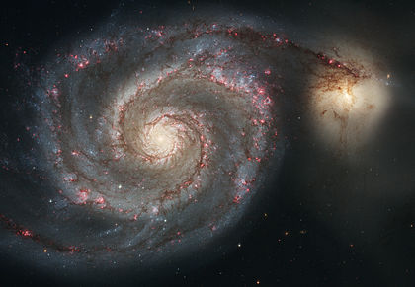

**“The Whirlpool Galaxy”**

1. Before moving forward we must clarify about wat is meant by mass and energy. **Mass** is the amount of content that a body has. Whereas, as for the term **Energy** there are more than one definition for different types of energy. One such definition states that energy is the quantitative property that must be transferred to an object in order to perform work on, or to heat, the object. Energy is a conserved quantity; the law of conservation of energy states that energy can be converted in form, but not created or destroyed. **It must be noted here that mass and energy are actually related to each other. In fact, mass is just another form of energy!**
2. This statement was verified my Albert Einstein when he told that mass and energy are not two different entities but are interchangeable forms of each other. This concept was hard to accept has people saw mass and energy as being completely distinct. They saw energy to be intangible, whereas mass was on the other hand tangible. However Einstein theoretically verified this point by giving an **Energy – Mass conversion formula: *E = mc2***
3. The above equation however uses the speed of light(*c = 3 x 108 m-sec-1*), which is a very great value. The conversation of mass to energy can be verified by ourselves(*when we burn a sheet of paper, we can see that the paper molecules are getting converted into heat energ*y). However the conversion of energy to mass cannot be verified in a DIY experiment as it requires a quite a lot setup to achieve the speed of light(*squared)*. However in Imperial College London the conversion of mass from energy has been successfully done, hence verifying Einstein’s theory and equation.

[https://www.forbes.com/sites/paulrodgers/2014/05/19/einstein-was-right- you-can-turn-energy-into-matter/#2c81348326ac](https://www.forbes.com/sites/paulrodgers/2014/05/19/einstein-was-right-%20%20%20%20%20%20you-can-turn-energy-into-matter/#2c81348326ac)

1. This equation is very much useful in generation power to run industries and making our lives easier. However by utilizing the matter(*mass)* that we use to generate power there is a lot of pollution and the efficiency of the system is very less. This problem can be solved to a great extent by utilizing micro-particle to convert energy(*nuclear power plants)*, but the wastage produced by a nuclear power plant is very toxic and extremely harmful for the environment. Other renewable sources of energy, such as *Solar panels, tidal power, hydro power, wind energy* can also be used but their efficiency is low, as they are very much dependent on climatic conditions. But since we don’t have any other alternative till now we are bound to use them.
2. However, **100% efficient energy can be obtained by using a black hole.** *Sir Roger Penrose* said that if in distant future, civilizations could harness a black hole(live near a black hole orbit or create a black hole in a laboratory) then by sending material in a spinning black hole, we could get out all of the converted energy. *But this is just a theoretical concept as black holes are way more complicated than that. They don’t just let you get away that easy!*